Regular expression
- A Regular Expression is a expression which represents a group of Strings according to a particular pattern.
Example:
- We can write a Regular Expression to represent all valid mail ids.
- We can write a Regular Expression to represent all valid mobile numbers.
The main important application areas of Regular Expression are:
- To implement validation logic.
- To develop Pattern matching applications.
- To develop translators like compilers, interpreters etc.
- To develop digital circuits.
- To develop communication protocols like TCP/IP, UDP etc.
Example:
import java.util.regex.*;
class RegularExpressionDemo
{
public static void main(String[] args)
{
int count=0;
Pattern p=Pattern.compile("ab");
Matcher m=p.matcher("abbbabbaba");
while(m.find())
{
count++;
System.out.println(m.start()+"------"+m.end()+"------"+m.group());
}
System.out.println("The no of occurences :"+count);
}
}
Output:
0------2------ab
4------6------ab
7------9------ab
The no of occurrences: 3
Pattern class:
- A Pattern object represents “compiled version of Regular Expression”.
- We can create a Pattern object by using compile() method of Pattern class.
public static Pattern compile(String regex);
Example:
Pattern p=Pattern.compile("ab");
Note: if we refer API we will get more information about pattern class.
Matcher:
- A Matcher object can be used to match character sequences against a Regular Expression. We can create a Matcher object by using matcher() method of Pattern class.
public Matcher matcher(String target);
Matcher m=p.matcher("abbbabbaba");
Important methods of Matcher class:
- boolean find();
- It attempts to find next match and returns true if it is available otherwise returns false.
- int start();
- Returns the start index of the match.
- int end();
- Returns the offset(equalize) after the last character matched.(or)
- Returns the end index of the matched.
- String group();
- Returns the matched Pattern.
Note: Pattern and Matcher classes are available in java.util.regex package.
Character classes:
[abc]-------------------Either ‘a’ or ‘b’ or ‘c’
[^abc] -----------------Except ‘a’ and ‘b’ and ‘c’
[a-z] --------------------Any lower case alphabet symbol
[A-Z] --------------------Any upper case alphabet symbol
[a-zA-Z] ----------------Any alphabet symbol
[0-9] --------------------Any digit from 0 to 9
[a-zA-Z0-9] ------------Any alphanumeric character
Example:
import java.util.regex.*;
class RegularExpressionDemo
{
public static void main(String[] args)
{
Pattern p=Pattern.compile("x");
Matcher m=p.matcher("a1b7@z#");
while(m.find())
{
System.out.println(m.start()+"-------"+m.group());
}
}
}
Output:
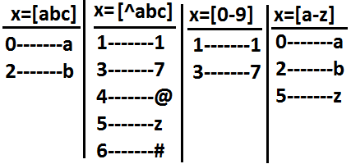
Predefined character classes:
\s---------------------space character
\d---------------------Any digit from o to 9[o-9]
\w---------------------Any word character[a-zA-Z0-9]
. ---------------------Any character including special characters.
Example:
import java.util.regex.*;
class RegularExpressionDemo
{
public static void main(String[] args)
{
Pattern p=Pattern.compile("x");
Matcher m=p.matcher("a1b7@z#");
while(m.find())
{
System.out.println(m.start()+"-------"+m.group());
}
}
}
Output:
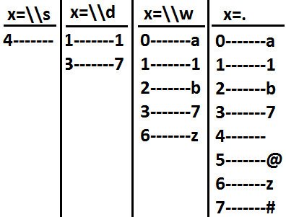
Quantifiers:
- Quantifiers can be used to specify no of characters to match.
a-----------------------Exactly one ‘a’
a+----------------------At least one ‘a’
a*----------------------Any no of a’s including zero number
a? ----------------------At most one ‘a’
Example:
import java.util.regex.*;
class RegularExpressionDemo
{
public static void main(String[] args)
{
Pattern p=Pattern.compile("x");
Matcher m=p.matcher("abaabaaab");
while(m.find())
{
System.out.println(m.start()+"-------"+m.group());
}
}
}
Output:
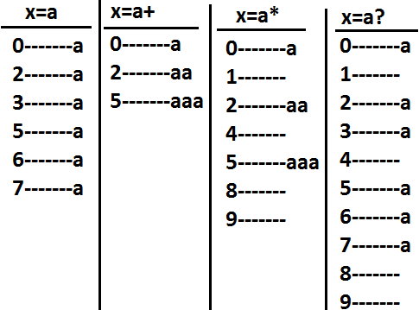
Pattern class split() method:
- Pattern class contains split() method to split the given string against a regular expression.
Example 1:
import java.util.regex.*;
class RegularExpressionDemo
{
public static void main(String[] args)
{
Pattern p=Pattern.compile("\\s");
String[] s=p.split("bhaskar software solutions");
for(String s1:s)
{
System.out.println(s1);//bhaskar
//software
//solutions
}
}
}
Example 2:
import java.util.regex.*;
class RegularExpressionDemo
{
public static void main(String[] args)
{
Pattern p=Pattern.compile("\\."); (or)[.]
String[] s=p.split("www.dugrajobs.com");
for(String s1:s)
{
System.out.println(s1);//www
//dugrajobs
//com
}
}
}
String class split() method:
- String class also contains split() method to split the given string against a regular expression.
Example:
import java.util.regex.*;
class RegularExpressionDemo
{
public static void main(String[] args)
{
String s="www.durgajobs.com";
String[] s1=s.split("\\.");
for(String s2:s1)
{
System.out.println(s2);//www
//durgajobs
//com
}
}
}
Note:
- String class split() method can take regular expression as argument where as pattern class split() method can take target string as the argument.
StringTokenizer:
- This class present in java.util package.
- It is a specially designed class to perform string tokenization.
Example 1:
import java.util.*;
class RegularExpressionDemo
{
public static void main(String[] args)
{
StringTokenizer st=new StringTokenizer("durga software solutions");
while(st.hasMoreTokens())
{
System.out.println(st.nextToken());//durga
//software
//solutions
}
}
}
- The default regular expression for the StringTokenizer is space.
Example 2:
import java.util.*;
class RegularExpressionDemo
{
public static void main(String[] args)
{
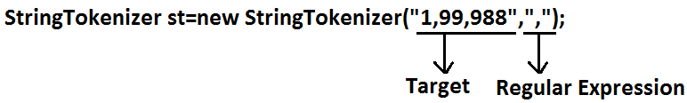
//StringTokenizer st=new StringTokenizer("1,99,988",",");
while(st.hasMoreTokens())
{
System.out.println(st.nextToken());//1
//99
//988
}
}
}
Requirement: Write a regular expression to represent all valid identifiers in yava language.
Rules:
The allowed characters are:
- a to z, A to Z, 0 to 9, -,#
- The 1st character should be alphabet symbol only.
- The length of the identifier should be at least 2.
Program:
import java.util.regex.*;
class RegularExpressionDemo
{
public static void main(String[] args)
{
Pattern p=Pattern.compile("[a-zA-Z][a-zA-Z0-9-#]+"); (or)
Pattern p=Pattern.compile("[a-zA-Z][a-zA-Z0-9-#][a-zA-Z0-9-#]*");
Matcher m=p.matcher(args[0]);
if(m.find()&&m.group().equals(args[0]))
{
System.out.println("valid identifier");
}
else
{
System.out.println("invalid identifier");
}

}
}
Output:
E:\scjp>javac RegularExpressionDemo.java
E:\scjp>java RegularExpressionDemo bhaskar
Valid identifier

E:\scjp>java RegularExpressionDemo ?bhaskar
Invalid identifier
Requirement: Write a regular expression to represent all mobile numbers.
Rules:
- Should contain exactly 10 digits.
- The 1st digit should be 7 to 9.
Program:
import java.util.regex.*;
class RegularExpressionDemo
{
public static void main(String[] args)
{
Pattern p=Pattern.compile("[7-9][0-9][0-9][0-9][0-9][0-9][0-9][0-9][0-9][0-9]");
//Pattern p=Pattern.compile("[7-9][0-9]{9}");
Matcher m=p.matcher(args[0]);
if(m.find()&&m.group().equals(args[0]))
{
System.out.println("valid number");
}
else
{
System.out.println("invalid number");
}
}
}
Analysis:
10 digits mobile:
[7-9][0-9][0-9][0-9][0-9][0-9][0-9][0-9][0-9][0-9] (or)
[7-9][0-9]{9}
Output:
E:\scjp>javac RegularExpressionDemo.java
E:\scjp>java RegularExpressionDemo 9989308279
Valid number
E:\scjp>java RegularExpressionDemo 6989308279
Invalid number
10 digits (or) 11 digits:
(0?[7-9][0-9]{9})
Output:
E:\scjp>javac RegularExpressionDemo.java
E:\scjp>java RegularExpressionDemo 9989308279
Valid number
E:\scjp>java RegularExpressionDemo 09989308279
Valid number
E:\scjp>java RegularExpressionDemo 919989308279
Invalid number
10 digits (0r) 11 digit (or) 12 digits:
(0|91)?[7-9][0-9]{9} (or)
(91)?(0?[7-9][0-9]{9})
E:\scjp>javac RegularExpressionDemo.java
E:\scjp>java RegularExpressionDemo 9989308279
Valid number
E:\scjp>java RegularExpressionDemo 09989308279
Valid number
E:\scjp>java RegularExpressionDemo 919989308279
Valid number
E:\scjp>java RegularExpressionDemo 69989308279
Invalid number
Requirement: Write a regular expression to represent all Mail Ids.
Program:
import java.util.regex.*;
class RegularExpressionDemo
{
public static void main(String[] args)
{
Pattern p=Pattern.compile("[a-zA-Z][a-zA-Z0-9-.]*@[a-zA-Z0-9]+([.][a-zA-Z]+)+");
Matcher m=p.matcher(args[0]);
if(m.find()&&m.group().equals(args[0]))
{
System.out.println("valid mail id");
}
else
{
System.out.println("invalid mail id");
}
}
}
Output:
E:\scjp>javac RegularExpressionDemo.java
E:\scjp>java RegularExpressionDemo bhaskar86.vaka@gmail.com
Valid mail id
E:\scjp>java RegularExpressionDemo 999bhaskar86.vaka@gmail.com
Invalid mail id
E:\scjp>java RegularExpressionDemo 999bhaskar86.vaka@gmail.co9
Invalid mail id
Requirement: Write a program to extract all valid mobile numbers from a file.
Diagram:
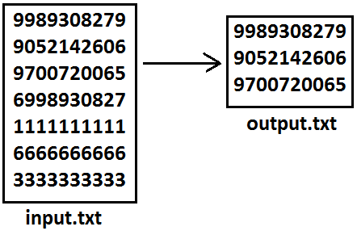
Program:
import java.util.regex.*;
import java.io.*;
class RegularExpressionDemo
{
public static void main(String[] args)throws IOException
{
PrintWriter out=new PrintWriter("output.txt");
BufferedReader br=new BufferedReader(new FileReader("input.txt"));
Pattern p=Pattern.compile("[7-9][0-9]{9}");
String line=br.readLine();
while(line!=null)
{
Matcher m=p.matcher(line);
while(m.find())
{
out.println(m.group());
}
line=br.readLine();
}
out.flush();
}
}
Requirement: Write a program to extract all Mail IDS from the File.
Note: In the above program replace mobile number regular expression with MAIL ID regular expression.
Requirement: Write a program to display all .txt file names present in E:\scjp folder.
Program:
import java.util.regex.*;
import java.io.*;
class RegularExpressionDemo
{
public static void main(String[] args)throws IOException
{
int count=0;
Pattern p=Pattern.compile("[a-zA-Z0-9-$.]+[.]txt");
File f=new File("E:\\scjp");
String[] s=f.list();
for(String s1:s)
{
Matcher m=p.matcher(s1);
if(m.find()&&m.group().equals(s1))
{
count++;
System.out.println(s1);
}
}
System.out.println(count);
}
}
Output:
input.txt
output.txt
outut.txt
3

